**Week 5**

**Creating Microservices for account and loan:**

**Account Microservice:**

D:\1234567\microservices\account

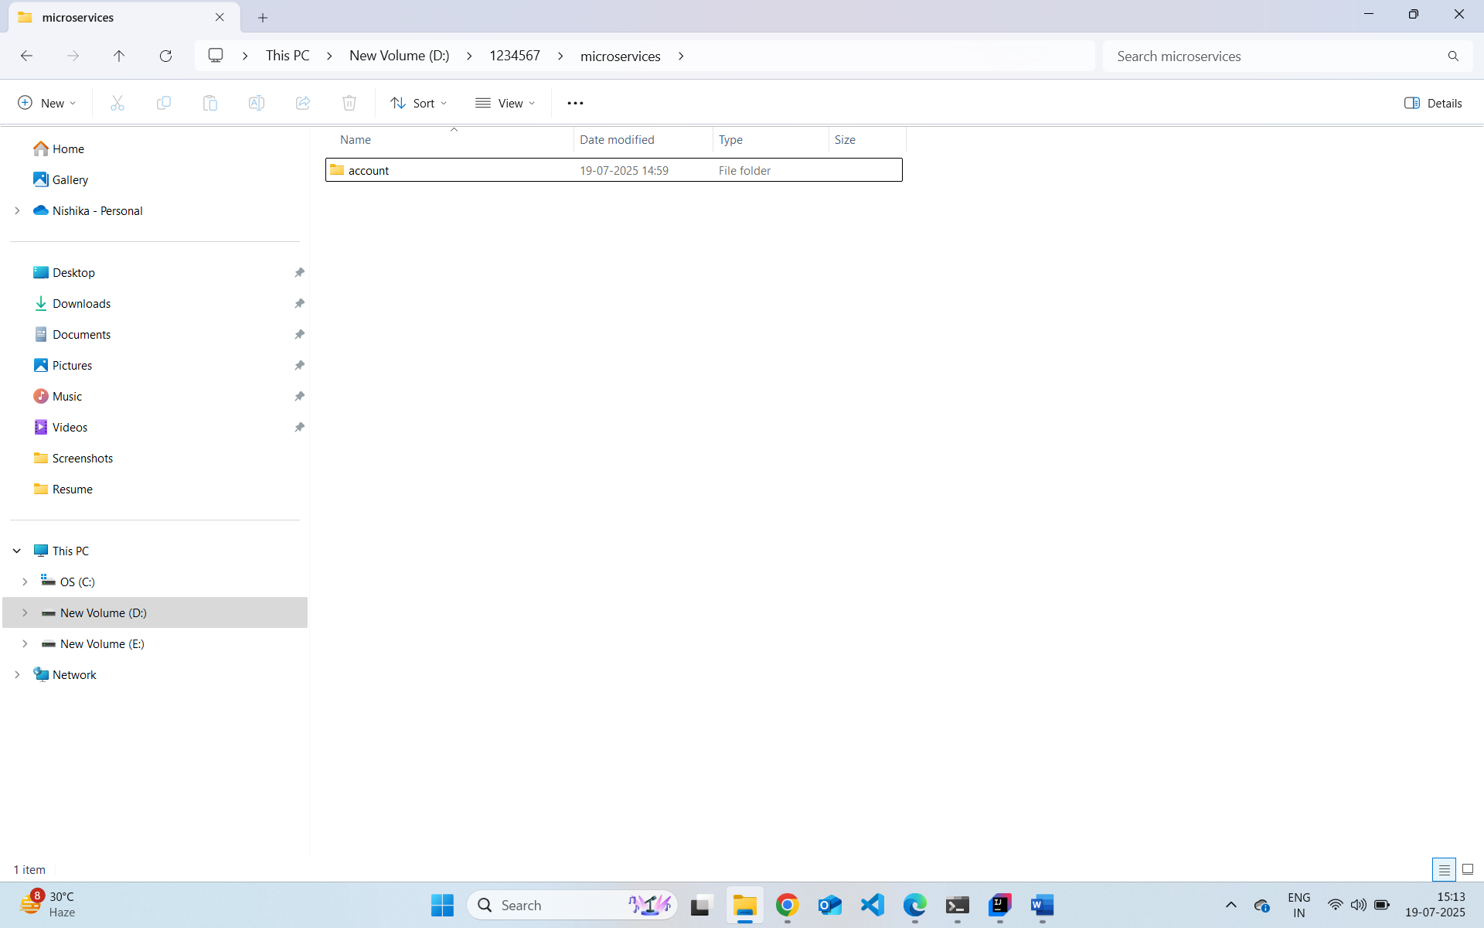

src/main/java/com/cognizant/account/controller/AccountController.java

http://localhost:8082/accounts/00987987973432

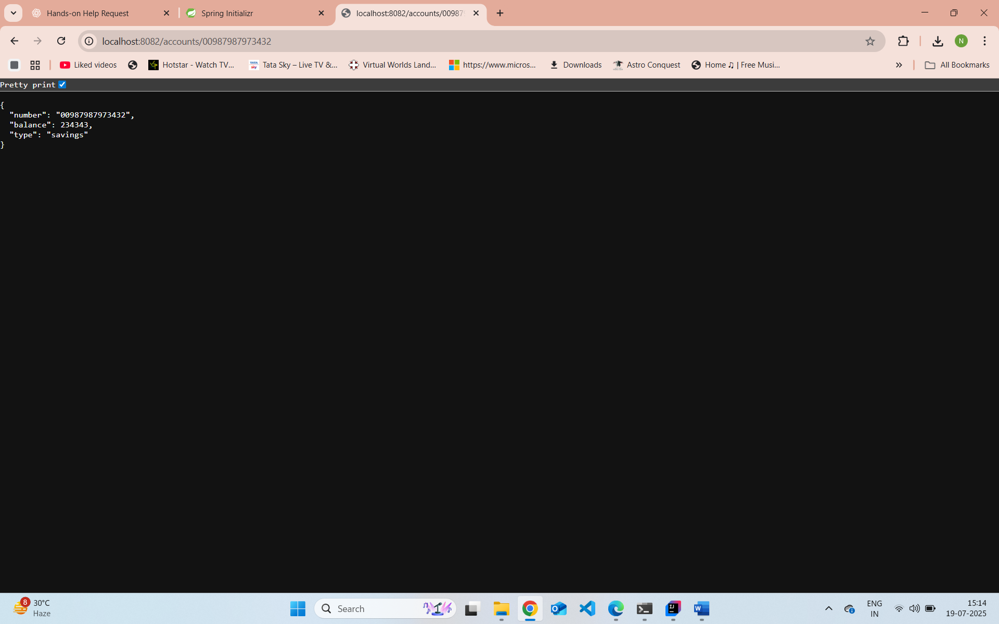

**Loan Microservice**

D:\1234567\microservices\loan

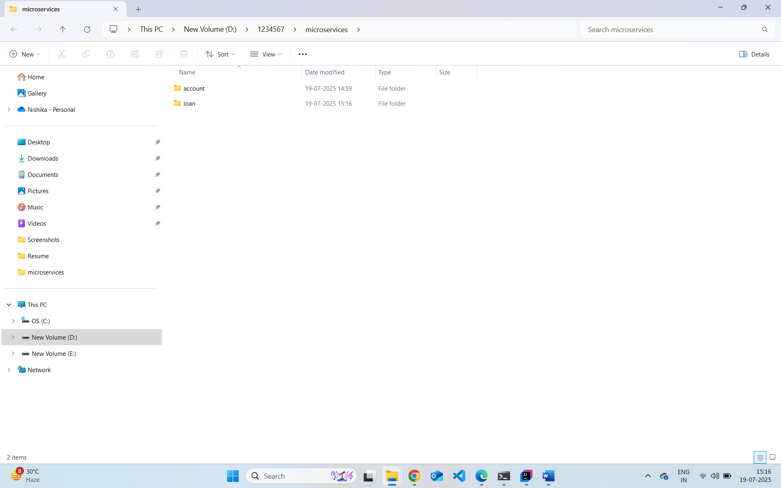

mvn clean package

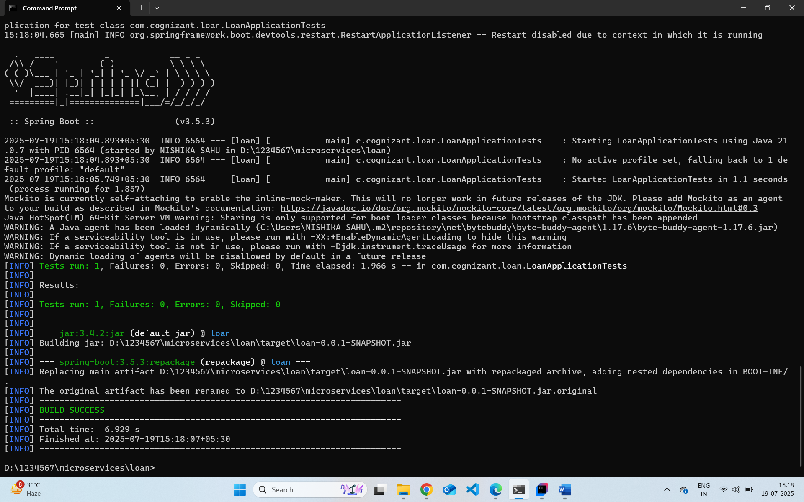

src/main/java/com/cognizant/loan/controller/LoanController.java

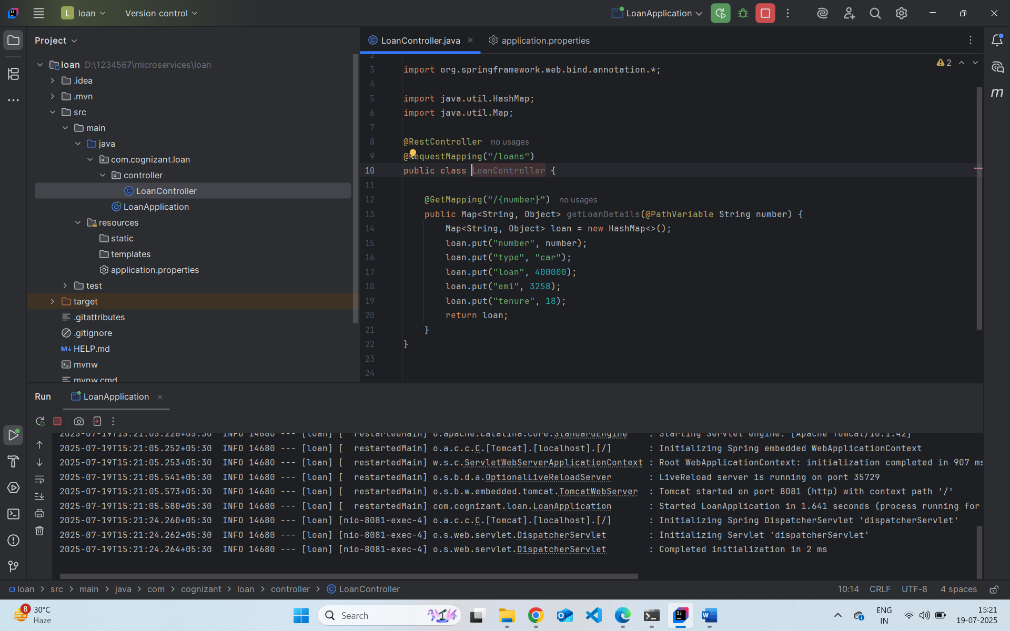

http://localhost:8081/loans/H00987987972342

